Getting to Know the Atlas of the Crop Wild Relatives of Paraguay

Explore the crop wild relatives of Paraguay with this Google Earth interface. Included you will find:
- information on 23 genepools of crops with wild relatives in Paraguay
- maps of the locations where herbarium and germplasm specimens of the species in each genepool were collected
- maps of the predicted distributions of these species
- maps of the patterns of richness of the genepools
- detailed records on the specimens used to create the maps

If you are not familiar with Google Earth, the user guide of this interface may help you
(http://earth.google.com/userguide/v4/). The following hints will help you get familiar with the contents and possibilities of the Atlas:

- The table of contents appears in the Places panel. It contains several folders that are not shown when you open the kml file. A “+” inside a square to the left of a folder indicates that there are one or several subfolders present. Click on this square to display the subfolders. Each subfolder can be deactivated by clicking again on the same square.
- The content is organized by crop genepools. To see all the genepools in the Atlas, click the “+“ in the square to the left of “Contents.”
- The blank squares to the left of the folder names control what information is displayed on the map. The information for any combination of genepools and species may be displayed at one time. Click a blank square to display the content of the corresponding subfolder.
- To display all records and predicted distributions – click the square next to “Crop genepools”.
- To display the records and predicted distribution for one genepool – click only the square next to the name of the genepool.
- To display the records and predicted distribution for one species – click only the square next to the name of the species.
- Any combination of the above records and predicted distributions may also be displayed.
- To further refine the display, you may choose to select only herbarium records, germplasm records, or the predicted distribution by clicking on the square to the left of one of these subfolders when they are present for a species.

Below is an example of a map that can be displayed in the interface. The map displays the information on Capsicum baccatum var. baccatum that corresponds to the folders activated by the clicked boxes in the table of contents. The blue crosses indicate where the herbarium and germplasm records were collected and the reddish orange area indicates the predicted distribution of this taxon.

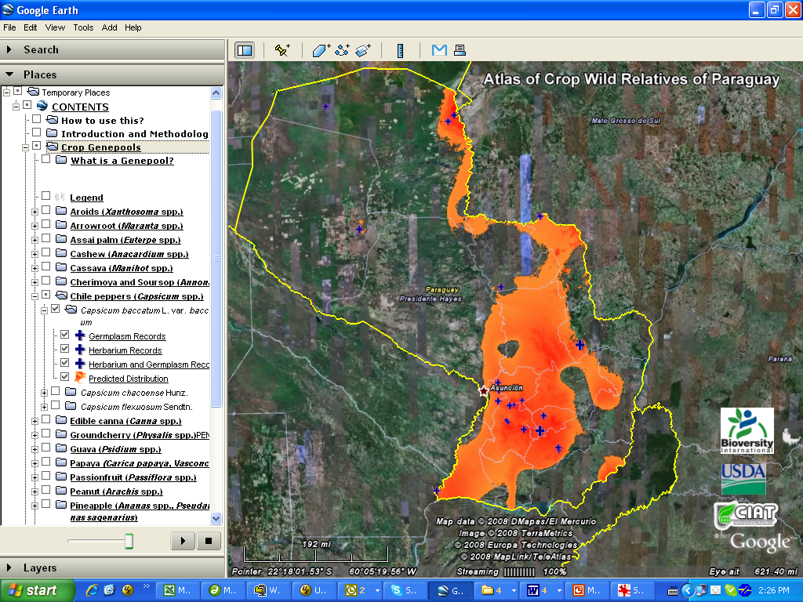

Click on any of the folders that are underlined (e.g., Contents, Crop Genepools, names of the genepools, herbarium records) to see additional information. Click on the symbol for a germplasm or herbarium record on the map to display more information about the record.

