CIATColsabanas Site TUTORIAL

This tutorial is intended to help you access the “CIATColsabanas

Login to CIATColsabanas:
http://ciat-colsabanas.cgxchange.org

- This will open the login screen below.

If you are a CGIAR user: Click on Sign in to CGXCHANGE.

If you are a non-CGIAR user (with a Gmail account) – click on ‘Sign in with a different account’. Instructions to login for non-CGIAR users
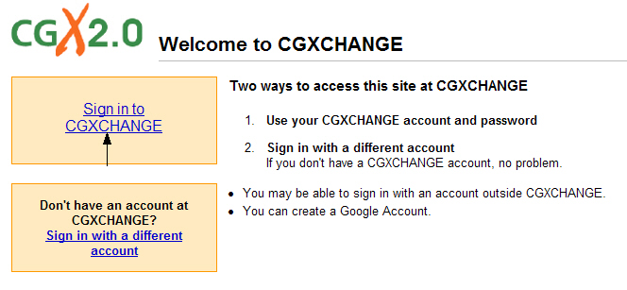

- Your user already exists on CGXCHANGE, so write your username and password (your usual network username and password) and click on SEND.

Note: If you are signing-in for the first time, follow these instructions: http://www.cgxchange.org/collaboration-tools/sign-in-to-cgxchange
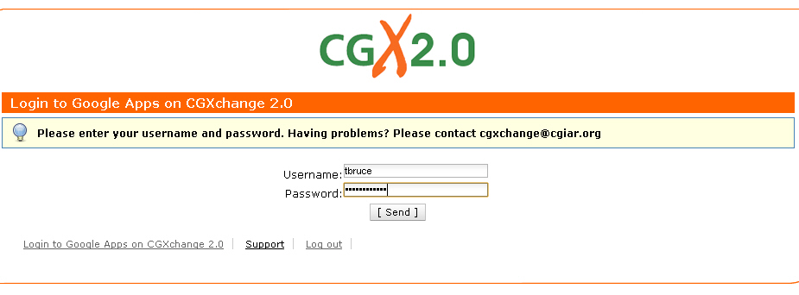
- You will see the main page of CIATColsabanas:

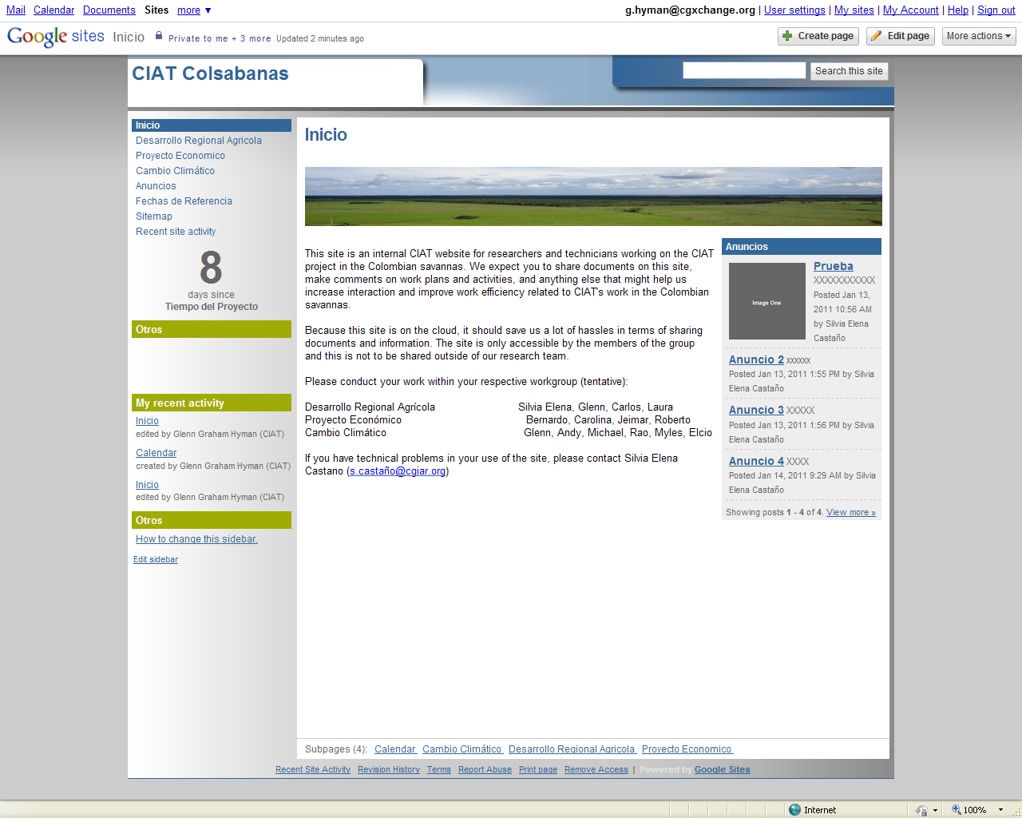

This site is an internal CIAT website for researchers and technicians working on the CIAT project in the Colombian savannas. We expect you to share documents on this site, make comments on work plans and activities, and anything else that might help us increase interaction and improve work efficiency related to CIAT's work in the Colombian savannas.

Because this site is on the cloud, it should save us a lot of hassles in terms of sharing documents and information. The site is only accessible by the members of the group and this is not to be shared outside of our research team.

Please conduct your work within your respective workgroup (tentative; hyperlinks to group on the left side navigation bar):

Desarrollo Regional Agrícola Silvia Elena, Glenn, Carlos, Laure
Proyecto Económico Bernardo, Carolina, Jeimar, Roberto
Cambio Climático Glenn, Andy, Michael, Rao, Myles, Elcio, Aracely

If you have technical problems in your use of the site, please contact Silvia Elena Castano (s.castaño@cgiar.org)

How to add comments on the Virtual Workspace?

To add comments on a particular page, click on the page using Navigation bar, scroll down to the bottom of the page and click on Comments as shown in the figure below:

Write your comments in the white box and when you are finished editing and you want to post your comment; click on ADD COMMENT:

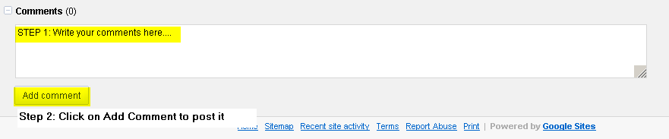

In the same way, you can upload documents, by clicking on "Attachments".

Support- if you have problems in the login:

If you have a problem when logging in, you can contact: Silvia Elena Castaño or the CGX Team at cgxchange@cgiar.org for assistance.

