This document describes the basic procedure used to create a KML document for use in Google Earth (GE) involving data created by CIAT and the Nature Conservancy. The project is intended to make available to a community of users the results of a series of models describing seven different threats to biodiversity across the continent of South America. This document is not intended as an in-depth technical reference, but rather a framework of how to go about creating or modifying similar Google Earth (GE) projects in the future. A wealth of very good technical information regarding GE and KML is available on line, through both Google itself as well as other third party users and developers. URLs to this on line documentation will be provided throughout the document, as well as in a section at the end of the document.

This document will explain sequentially the process steps used to create a Google Earth KML file called TNC_threats.kml. It will describe the process of preparing ESRI raster as well as vector data for use in Google Earth. It will also briefly describe the use of networklinks to greatly expand the amount of data that can be offered through GE, as well as using KML styles, and the inclusion of metadata in GE. A brief description specific to TNC_threats.kml will also be provided, describing the file/directory structure of the data as it resides on the Uso de Tierra http server. At the end of the document a list of useful KML reference URLs will be provided.

Convert GRID to PNG Image
In order to display ESRI GRID data in Google Earth, a GRID must first be converted to a true image format. Though GE supports a number of different image formats, .png is the best image type to use because .png alone supports transparency within the image (i.e. NoData cells can appear transparent). Unfortunately, ArcMap can only export GRID data as a .tif or .img file, so the GRID must first be exported from ArcMap as a .tif file, and subsequently converted to .png with another piece of graphics software.

Two points merit discussion on exporting a GRID to a .tif file within ArcMap. First, the display of raster data in ArcMap is greatly enhanced by applying a stretch to the data, wherein a color scheme is applied to the real data values in a manner such that the maximum number of colors are applied to the variation present within the data. ArcMap does this by default, but it is important to include these stretched color values in the exported image product. Secondly, when a color scheme (i.e. red monochromatic) is applied to a GRID, the exported .tif product must be saved as a three-band (RGB) image in order to preserve the color scheme in the final image product. Exporting from ArcMap as a three-band image greatly increase the image size (triples it), as well as the processing time required for export, but it is essential in order to preserve the desired appearance. Command line ArcInfo/GRID is much faster at exporting a GRID as a .tif file, however the time required to set up both the color stretch as well as the color scheme (i.e. creating a colormap file) within ArcInfo/GRID makes this option undesirable. Figure 1 below is a screen dump of a correctly formatted GRID export dialogue within ArcMap. This export function can be accessed by right clicking on the target GRID in the ArcMap layers list, and selecting Data > Export Data. Notice that the “Use Renderer” and “Force RGB” check boxes are selected, and the selected format is “TIFF”.

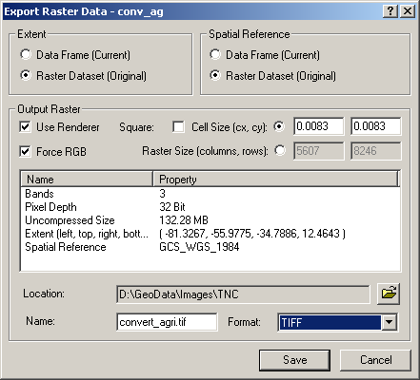

Figure 1 GRID export interface, ArcMAP

Once a three-band .tif image has been successfully exported, it must then be converted to a .png file with the appropriate RGB combination identified as transparent (usually 0,0,0). IrfanView is an easy to use and free piece of image software that can easily accomplish the conversion to .png. IrfanView can be downloaded for free at http://www.irfanview.com/.

Create an Image Super Overlay
With a little bit of finesse, and some knowledge of KML, images can be easily viewed within Google Earth. However, GE has real trouble dealing with images greater in dimension than 2000 x 2000 pixels (according to Google), and such images, if imported into GE, will suffer a severe deterioration in resolution. Actually, the problem is not so much GE as it is the capacity of the typical graphics card and the resolution of most monitors. Despite Google’s claim regarding 2000 x 2000 dimension images, to retain the resolution of the original product, any images used in GE should not exceed about 400 x 400 in dimension. Obviously, this presents a problem when a developer wants to include large continent-wide or global raster data sets.

Fortunately, recent versions of KML offer a nice solution to this problem. By using the KML elements <Region> and <NetworkLink>, along with a technique known as Super Overlay (and some inexpensive software that automates the process), larger high-resolution imagery can easily be made available in Google Earth. This document will not present a detailed explanation of the aforementioned KML elements and techniques, as a wealth of very thorough documentation on these subjects is available on line. See the following URLs for a good discussion of these topics: http://earth.google.com/kml/kml_21tutorial.html#workingregions , http://earth.google.com/kml/kml_21tutorial.html#superoverlays ,

In essence, Super Overlay is the process of taking a single large image file, and breaking it up into many smaller sub-images or tiles. Some of these sub-images retain the resolution of the original image, and others have been re-sampled to varying degrees of reduced resolution. Using the <Region> and <NetworkLink> elements in KML, a Super Overlay displays sub-images of different resolutions to the client depending on the scale at which the client is viewing the data. At a very small scale, where the client is viewing a large area (such as an entire continent), only the sub-images of the coarsest resolution are displayed. As the client zooms in farther, viewing less and less area at an increasing scale, higher resolution images are displayed. Finally, when the client is zoomed into a large enough scale (elevation in Google-speak), the full resolution sub-images are displayed. At any one time, no more than four to six image tiles are displayed on screen.

Setting up a Super Overlay by hand for anything more than a few images would be a time consuming and tedious process. Thanks to a prolific and generous GE user community, there are a number of software tools that have been developed to automate the Super Overlay process for the developer. The best among these is SuperOverlay (v1.3.2), which provides a nice graphical user interface with several useful options for easily setting up a Super Overlay. SuperOverlay can be downloaded as a free 7-day trial, or can be purchased for $20 USD at http://gis.mi-perm.ru/programs/superoverlay. This same URL contains a very useful set of instruction on how to use the software, and a list of all the settings available and what they mean. This tool is highly recommended. Figure 2 below is a screen dump of SuperOverlay as it was set up to run a continent-wide image data file for South America.

The settings used below will not be described in detail here, as a sound explanation of each is provided at the URL above. However, there are a couple of important settings to point out. The location of the new images and .kml files must be explicitly defined in the upper right corner. Also required are the bounding coordinates of the extent the image covers (taken from the original GRID data set). Also, make sure that if transparency is desired in the output that PNG is selected as the format (the input image must also be .png). A number of different options are available for the re-sampling type, with slightly better results noticed using bicubic sampling. As far as LOD (level of detail, explained in the user instructions), between four and six is probably most appropriate, but this will depend on the size and geographic extent of the image being processed. Finally, under “Packing into KMZ” the user has a number of options. If the resulting data is to be hosted on an http server, then the “Don’t pack” option is most appropriate, as it ensures that all path names will be correct on the http server.
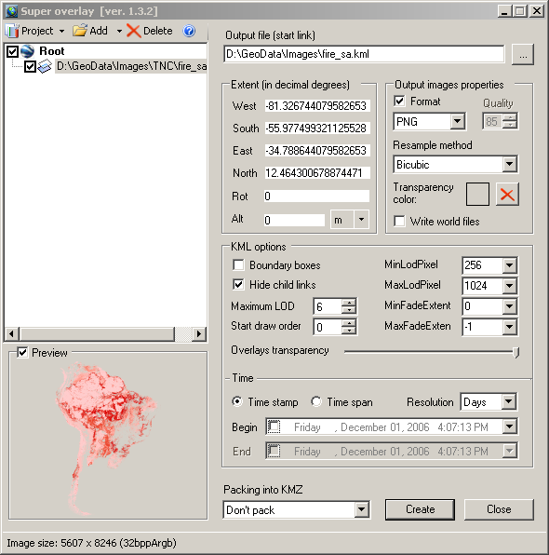

Figure 2 SuperOverlay ready to run a continent-wide data set for South America

As an example of the output produced by this process, a 1km resolution image file of all of South America (5607 x 8246 pixels) was processed by SuperOverlay v.1.3.2. The output produced consisted of 1,368 .png files and 1,368 accompanying .kml files. Each individual .kml file contains a <Region> element describing the “scale” at which the associated image should display, and a <NetworkLink> element identifying the .kml file(s) to access once either the maximum or minimum scale for that image has been exceeded.

Convert Shapefile Vector Data for Use in Google Earth
Preparing shapefile vector data for use in GE is a much simpler and faster process than preparing raster/imagery data. Once again, there are a number of tools that have been created for this process. One good option is a product called Arc2Earth, which has been created as an extension for ArcMap (http://www.arc2earth.com). This extension is available as a free 30-day trial, or can be purchased for $99 USD. The extension is straightforward and easy to use, and provides many options regarding how the data should be exported. A .pdf document providing detailed information on the extension is available at http://www.arc2earth.com/products/A2E_Brochure.pdf. A screen dump of Arc2Earth is presented below in Figure 3. Again, to understand all that this extension can do, the documentation should be referenced.

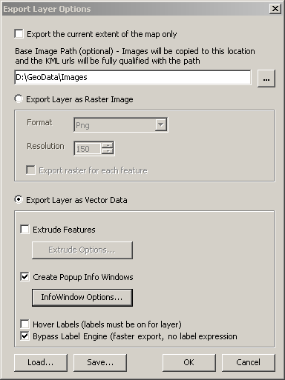

Figure 3 Arc2Earh ready to export vector point data

The result of running vector data through the Arc2Earth extension is a .kml file which contains a reference to every feature in the data set (in this case a Placemark for each point in the layer), as well as a graphics file used to display each feature in GE, and, optionally, information from the shapefile attribute table which is available as a pop-up balloon in GE when the user clicks on a point feature in the display.

While Arc2Earth works very well, the output product can be substantially improved by wading into the resulting .kml file and tweaking some of the KML code that Arc2Earth produces. The possibilities in this regard are endless, but a few essential improvements will be described here.

One annoying thing this tool does is place an “Arc2Earth” text string in each and every balloon that pops up in GE when the user clicks on a feature in the viewer to examine available attribute data. This little bit of self-promotion on the part of Arc2Earth can be easily removed by locating the reference in the .kml file and removing it completely. This bit of extra code will be included with every individual feature (point, line, or poly), so it is best to use a search and replace tool in a text or code editor to remove every instance of it. Another odd twist is that Arc2Earth saves a graphic file (.png) for each and every feature that it is exporting for use in GE. In the case of point data in which all features are symbolized identically, this results in hundreds or even thousand of identical graphic images being produced (depending on the number of records in the original shapefile). Besides being a waste of space on a server, GE performance is seriously degraded by having to download, cache, and draw hundreds of different graphic files which all display exactly the same thing. This can be solved by altering the .kml code so that all points refer to the same .png file, rather than each point referring to its own individual .png file. Doing so greatly improves the speed at which a vector layer displays in GE. Once this is accomplished, all extra .png image files can be removed from the server.

Using NetworkLinks to Create a Master KML File
Once you have created a series of .kml files, for either image or vector data, all of these .kml files can be referenced from a single “master” .kml file using the KML element <NetworkLink>. A networklink basically allows an external .kml file to be referenced from within a local .kml document. There is no limit to the number of networklinks that a single .kml file can reference. The syntax for setting up a networklink is very simple, and an excellent description can be found on line in Google’s KML (2.1) tag reference, http://earth.google.com/kml/kml_tags_21.html. The only requirement for a network link is that the client who is attempting to utilize the file must have access to the location where the network linked .kml resides, preferably on an http server.

One big advantage of using networklinks, in addition to the convenience of not having to store massive amounts of information within a single .kml file, is that networklinked .kml files are dynamically updated. When a user accesses a network link, they are getting the most updated version of the linked .kml file on the server. This represents a big advantage over simply distributing zipped .kmz files, which are static and in no way dynamic. When a .kml file is updated on an http server, any network links that point to that .kml file will always return to the client the most current version of the .kml file.

Using KML Styles
One really nice formatting feature available in KML is the use of styles. Though distinct from cascading HTML styles, the concept is exactly the same. There are over ten style elements available in KML, dealing with everything from labels, to icons, to list items, to pop-up balloons. Each style element dictates the appearance and behavior of a particular component within GE. The KML tag reference URL listed above contains a thorough description of all the style elements available in KML. Of particular usefulness is the <ListStyle> element. The <ListStyle> element provides the developer a lot of flexibility in how items in the Places panel (a.k.a. Table of Contents) appear in GE, as well as other functionality that can be added to list item headings, such as hyperlinks, image rollovers, additional/alternate icons, etc.

Metadata
If access to metadata is to be included with the .kml you are developing, there are a number of ways to achieve this. The simplest way is to simply include a <description> tag inside of your feature reference. This can be done regardless of whether you are using a networklink, placemark, point, etc. The <description> tag causes a pop-up balloon to appear in the GE viewer when the client clicks an item heading in the Places panel. The content within the pop-up balloon is all HTML derived, so you can add just about anything you want within the balloon, including text, images, hyperlinks, image rollovers, etc.

An example of how you might include metadata in GE would be to include the <description> element within a <networklink>. When the user clicks on the networklink item in the Places panel, a pop-up balloon appears which contains the exact text from the abstract section of the metadata file, below which is a hyperlink that will open up a web page in a browser window containing the complete metadata file. See Figure 4 below for an example of how such a pop-up balloon would appear in GE. Metadata could also be made available by clicking a check box on and off in the Places panel.

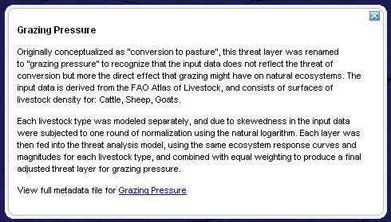

Figure 4 Pop-up balloon in GE containing metadata abstract and hyperlink

Directory Structure Behind TNC_threats.kml
Now a brief description of how the data itself is stored. The directory structure containing the data that supports TNC_threats.kml is fairly straightforward, and could be easily re-organized as long as the .kml file itself is altered to reflect the new data and folder locations. See Figure 5 for a screen dump of the directory structure as it appears in the root website directory of the Uso de Tierra http server.

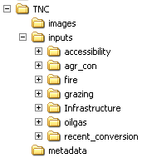

Figure 5 Directory structure behind TNC_threats.kml

All of the image data and supporting KML files for the seven threat models (as well as the aggregate threat layer) are located within the root folder called TNC. This consists of thousands of tiled images and their supporting .kml files. The directory TNC/images contains the logo images used in the sight, as well as other miscellaneous image files such as icons and markers. The TNC/inputs directory contains seven folders, each of which contain images and supporting .kml files which provide access to the data layers used as inputs to the seven threat models. Finally, the TNC/metadata folder contains HTML metadata files for each of the seven threat models as well as the aggregate threat layer. These are the metadata files that are accessed when the client clicks on the threat headings in the Places panel in GE.

Google Earth On Line Documentation
KML tag reference: http://earth.google.com/kml/kml_tags_21.html
KML tutorial: http://earth.google.com/kml/kml_tut.html
Getting started with GE: http://earth.google.com/userguide/v4/
GE on line help: http://www.keyhole.com/GoogleEarthHelp/wf_startfs.htm
GE Community (user blog): http://bbs.keyhole.com/ubb/ubbthreads.php/Cat/0
SuperOverlay tool: http://gis.mi-perm.ru/programs/superoverlay/
Arc2Earth download & documentation: http://www.arc2earth.com
IrfanView image software: http://www.irfanview.com

